CIS2324 EXAM1 REVIEW

PART A: (60 points)

Between 20 and 40 multiple choice questions from Chapters 1 through 4 primarily covering the following concepts:

* Try . . . Catch
* Put a value into a variable; what will display on the form?
* Process a sequence of IF . . . code by hand, what will the resulting values be?
* How do we program a value to be displayed in a textbox or a label?
* What events happen when we start running our VB program in addition to the SUBS that we coded behind event handling buttons?
* Local variables vs global (form) variables. How are they different.
* How are arithmetic operations evaluated?
* Run a block of code by hand and figure out what the end result will be.
* Know the various controls that we have used so far to build programs, what we used them for and which properties of each control we emphasized and used mostly. For example when we used checkboxes we used their checked attribute the most.
* How is a set of separate if .. then different from a chained if .. then . . elseif ..

EXAM Part B: (40 points)

You will be given the gui and asked to develop the code for a program such as the one below:

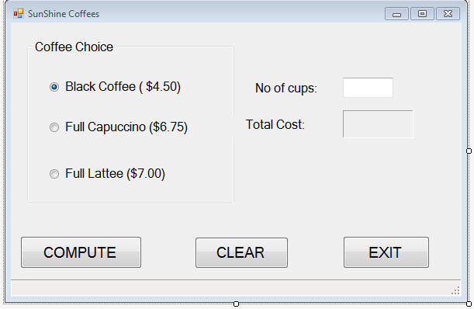

REQUIREMENTS:

1. The number of cups requested must be between 1 and 6; a numeric integer digit. Otherwise the program cannot proceed and must halt execution.
2. You must use a chained IF . . Then . .

Elseif . .

Visual Basic coding technique to write your program to process the group of radiobuttons.